JSSC,SDSS, November,2015

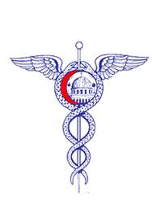
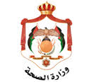
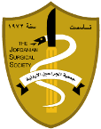

The 43^{rd.}Jordanian International Conference of Jordanian Surgical Society

The 3^{rd.} Scientific Day of the Surgical Specialty Ministry of Health

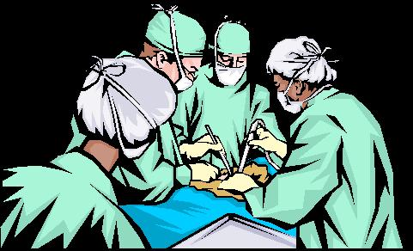

26-28 November, 2015
Conference Center – Al Bashir Hospital
Amman

SCIENTIFIC PROGRAM

JSSC,SDSS, November,2015

DAY ONE
THURSDAY Nov.26, 2015

Opening Lecture (10:00)
Moderator: Salam Daradkeh

Recent Ethical and Practical Rules in Safe Surgical Practice. 15min.
Mustafa Steitiyeh

Session I: Hepato Pancreato Biliary & Organ Transplantation surgery
(10:15 -13:00)
Moderators: Khaled Al Ajarmeh, Awad Al Dmour, Iyad Qarqaz
Approach to the Patients with Post Cholecystectomy Biliary complications.  Abdel Hadi Al Breizat | 30 min.
Controversial Issues in Pancreatic Cancer Management.  Salam Daradkeh | 30 min.
Acute Pancreatitis  Ali Al-Sarira | 30 min.
General Principles in Solid organs Transplantation.  Mohammad Al Kofahi | 30 min.
Liver Transplantation.  Saeb Hammoudi | 25 min.
Early Versus Interval Cholecystectomy  Ashraf Fauri | 10 min.
Lunch Break13:00-14:00

JSSC,SDSS, November,2015

DAY ONE
THURSDAY Nov.26, 2015

Session II: (Trauma I)
(14:00 -15:40)
Moderators: Mahmoud Odat, Abdel Rahman Shdefat

Introduction 10 min.
Mahmoud Odat

Primary Trauma Care.  FaiezAlhmoud | 30 min.
Management of Patients with Head Injury.  Abdullah Al Akayleh | 20 min.
Nick Trauma  Nader Al Bsoul | 20 min.
Tracheostomy: Indications and Technique.  Mohamed Saadah | 20 min.
Coffee Break 15:40-16:00

JSSC,SDSS, November,2015

DAY ONE
THURSDAY Nov.26, 2015

Session III: (Trauma II)
(16:00 -17:30)
Moderators: Sabir Rawashdeh, Faiez Alhmoud.

Periphery Vascular Injuries.  Atef Abu Taha | 20 min.
Emergencies in Urology.  YasinIdweini | 20 min.
Pediatric Surgery Emergency  Ali Al Shoubaki | 20 min.
Management of Patients with Spine Injury.  OmranJanbek | 20 min.
إجتماع الهيئة العامة لجمعية الجراحين الأردنيين الساعة 17:30 مساءاً
مركز المؤتمرات – مستشفى البشير

JSSC,SDSS, November,2015
DAY TWO
FRIDAY Nov.27, 2015

Session IV: (Meshelenious)
(08:30 -11:05)
Moderators: Zaki Qulaghasi, Hasan Madi, Osama Hamed

New Trends in the Management of Ano-Rectal Conditions.  Dr. Amer Amireh |  | 20 min.
Colo-rectal Carcinoma among Doctors and Relatives in West Bank 1974-2015.  DR. Osama Bashtawi |  | 15 min.
New trends in the Management of Diabetic Foot.  Dr. Hazem Habboub |  | 30 min.
Skin flaps: Indications, Types and Technique.  Dr. Mahmoud Al Bataineh |  | 20 min.
Thyroglossal Duct Cysts, Beware of Multiplicity.  Dr. Hassan Al Jadid |  | 20 min.
Endovenous Radiofrequency Ablation of Varicose veins  Sabir Rawashdeh |  | 20 min.
Risk factors for anastomotic leak in colorectal surgery  Dr. Khaled Beerdawood |  | 10 min.
None Repair technique for management of adult male indirect inguinal hernia less than 30 years old  Dr. Khaled Beerdawood |  | 10 min.
Fat Embolism Syndrome (Case Presentation).  Dr. Taher Faydi |  | 10 min.
Jumaa Prayer & Lunch Break 11:00-13:30

JSSC,SDSS, November,2015

DAY TWO
FRIDAY Nov.27, 2015

Session V: Nursing Session
(13:30-15:40)
Moderators: Ayman Hazineh, MunaRadi

Anti-Bacterial Sutures  Mohammad Othman | 30 min.
Wound Care  Arwa Al Sadeq | 20 min.
Sutures and needles  Osama Al Qa’qaa | 30 min.
OR. Manager Characteristics  TamamMojahed | 30 min.

JSSC,SDSS, November,2015

SCIENTIFIC PROGRAM
DAY THREE
SATURDAY Nov.28, 2015

Live Surgery Transmission
from Operating Theater to the main Conference Hall
Al Bashir Hospital
Full Day (09:00 -15:00)

Luncheon Lecture (MSD)
The Role of Ertapenem in Antibiotic Resistance, (30min.)
Enas Khoury

